**Bugs:**

**1. Payment**

Expected Output: 75

Actual Output: 70

Screenshot:

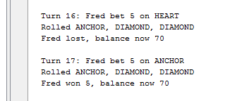

**2. BettingLimitNotUptoZero**

Expected Output: Fred now has balance 0

Actual Output: Fred now has balance 5

Screenshot:

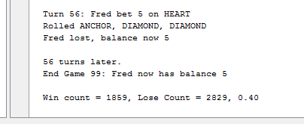

**3. WinPercentage**

Expected Output: Win percentage below 0.42

Actual Output: Win percentage 0.61

Screenshot:

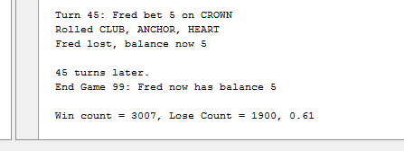

**4. NoRandomFaces**

Expected Output: Rolled should be random in different turns.

Actual Output: Rolled output is always the same.

Screenshot:

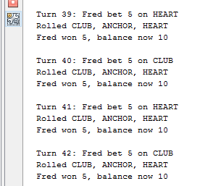

**5. NoSpade**

Expected Output: Spade should occur on bet and rolls.

Actual Output: No occurrences of Spade on bet and rolls.

Screenshot:

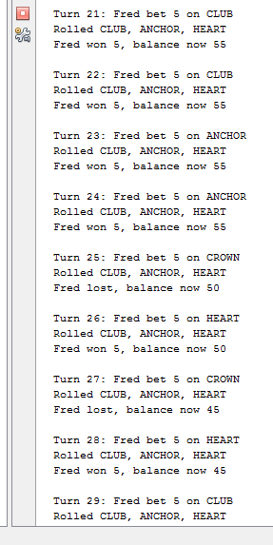

**6. QuitGame**

Expected Output: User should be prompted to continue or quit the game.

Actual Output: User is not asked whether to continue or quit the game.

Screenshot:

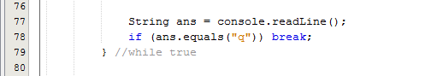

**7. BetAmount**

Expected Output: Bet amount should not be 0, should display error message.

Actual Output: Runs the program, does not display any error message.

Screenshot:

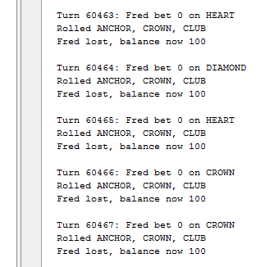

**9. AgeRestriction**

Expected Output: Should ask age verification before starting the game.

Actual Output: Does not ask for the age verification before starting the game.

**10. Minimum/MaximumWagers**

Expected Output: Should give the display of Minimum and Maximum wagers.

Actual Output: Does not display the Minimum and Maximum wagers.